NETBALL - GCC wins Under 15 and Open Competition
On Friday the 22nd of February, Good Counsel College entered two under 15’s and one open netball team into the district trials held at Innisfail State College. All up 26 girls played in a round robin competition against Tully and ISC throughout the afternoon with all three teams showing excellent sportsmanship. The open team was impressive defeating ISC(2) and Tully easily and drawing with the ISC(1) team in the rounds. The final was between GCC and ISC(1) in front of a large crowd and saw GCC skip out to a six nil lead before ISC came back within two points at half time. The girls fought hard and were rewarded with a 16-14 win to take out the championships. Four players were recognised for their efforts and gained selection in the district team. Congratulations to Micaela Crompton, Caitlin Braithwaite, Kayla Zecchinati and Madison Beare.
The under 15 final was played out between GCC(1) and the GCC(2) team after both teams won against ISC(1 and 2) and Tully. Both teams played extremely well with the GCC(1) team coming away with a convincing win. Eight girls were selected in the district team of ten players: Brittany Fahey, Breanna Fahey, Abbey Hurney, Gabrielle Holder, Emily Boevink, Rebecca O’Connor, Chyra Zecchinati and Kaitlin Lynch.
The peninsula trials will be held at ISC on Friday 8th of March. We wish these girls all the best.
Miss Kate Haren
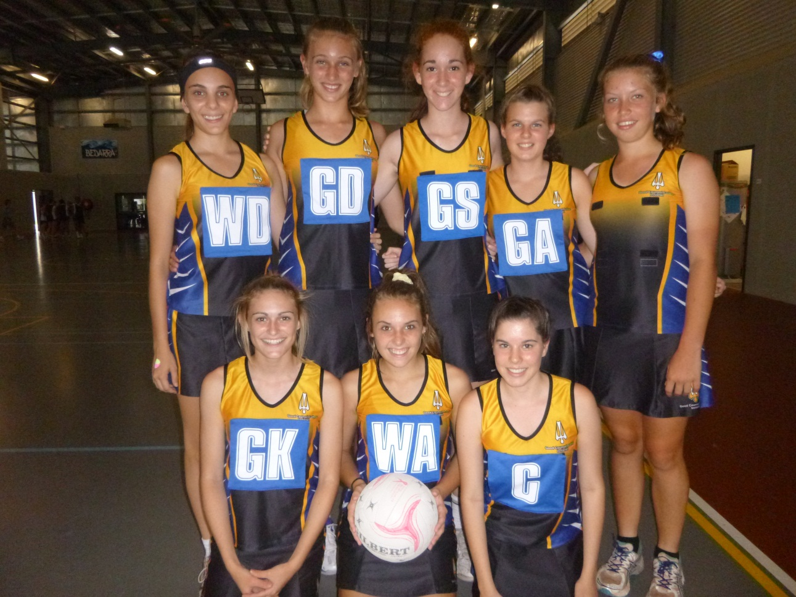
Under 15 Netball A – Back(L-R): Laken Ruddell, Emily Boevink, Chyra Zecchinati, Breanna Fahey and Gabrielle Holder. Front: Rebecca O’Connor, Abbey Hurney and Brittany Fahey.

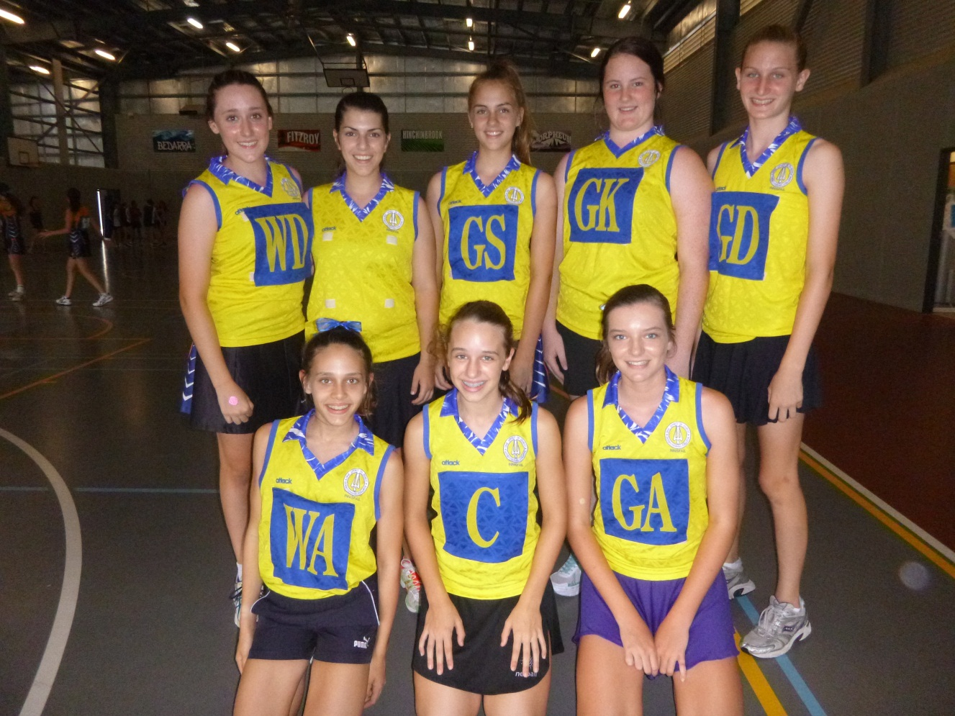
Under 15 Netball B – Back(L-R): Brenna Lindsay, Courtney Baldissera, Kaitlin Lynch, Keira Plath, Keely Jones. Front: Lori Favero, Halle Misfud and Tayla Cameron.

Open Netball – Back(L-R): Adrienne Worth, Kayla Zecchinati, Micaela Crompton, Madison Beare and Jessica-Lee O’Connor. Front: Caitlin Braithwaite, Shay-Lee Plath, Claudia Galea and Lauren Braithwaite.

