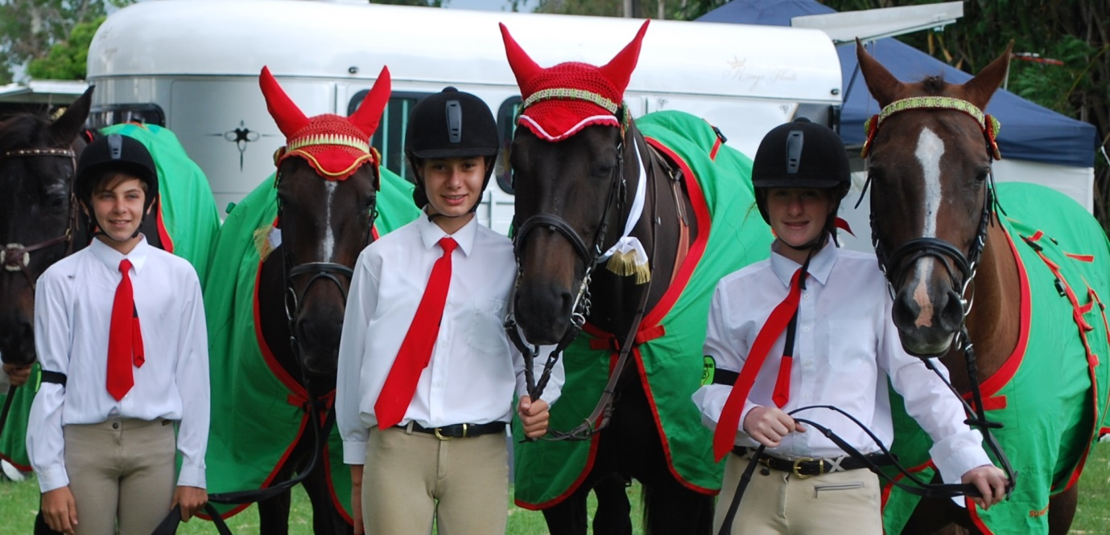

State Equitation and Showjumping: Conor Pizzolato and his horse New York Shadow, Bobbie-lee Philips and horse Miss Jessica and Brielle Cavallaro with her horse Misty Morning