Swimming Carnival 2016
The Good Counsel College swimming carnival was held on Thursday 14th April at the Innisfail swimming pool. The day started with rain but this couldn’t dampen the high spirits of the house captains that marched their way into the arena and led their team to the first cheering competition of the day. A number of novelty races were held throughout the day that included all competitors and spectators and allowed each team to show their passion for teamwork, culminating in the awarding of the highly sought after Spirit Cup. This year there was no denying the mighty McKillop team as they showed that getting in to the spirit of the day is what our carnival is all about.
The competition in the pool was just as fierce in the four strokes and in the under 15 girls it was so close that it could not be split for overall champion. Congratulations on fantastic performances by all our age champions and runner ups for 2016…
Under 12  Champion girl: Piper Camilleri  Runner up:  Amy Daly  Champion boy: Ryan Pedrola  Runner up:  Kent Nielsen | Under 13  Champion girl: Caitlin Spinella  Runner up: Jessica Magnanini  Champion boy: Bryce Maley  Runner up:  Simeon Edwards | Under 14  Champion girl: Gabrielle Hall  Runner up:  Jorjah Karamaena  Champion boy: Daley Jones  Runner up:  Eamonn Ross | Under 15  Champion girls: Rylee Wallace  and  Kate Boevink  Champion boy: Flynn Lowrey  Runner up: Ethan Darveniza | Under 16  Champion girl: Madeleine England  Runner up:  Jade Maley  Champion boy:  Shinji Hain  Runner up:  Cahil Abraham | Open  Champion girl: Keely Jones  Runner up: Gabrielle Holder  Champion boy: James De Angeli  Runner up: James Pontil

The Inter-house swimming trophy is the other big accolade each team competes for and this year it was the Polding team that was victorious again. Polding was able take out the majority of age champions and also entered teams in all the relays, finishing the day with the highest number of points.

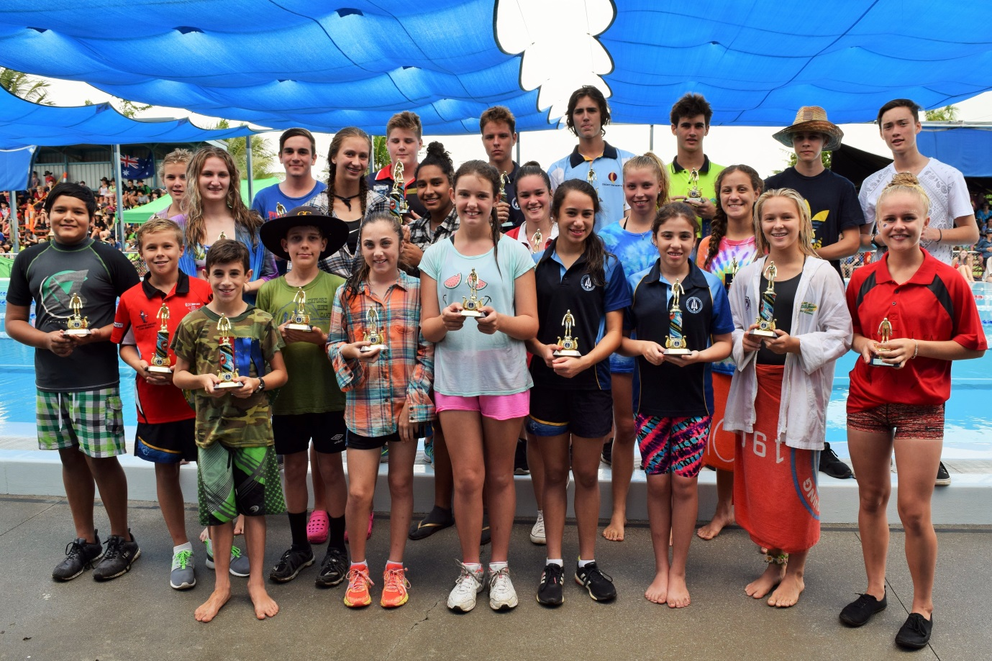
Age Champions and Runner ups 2016
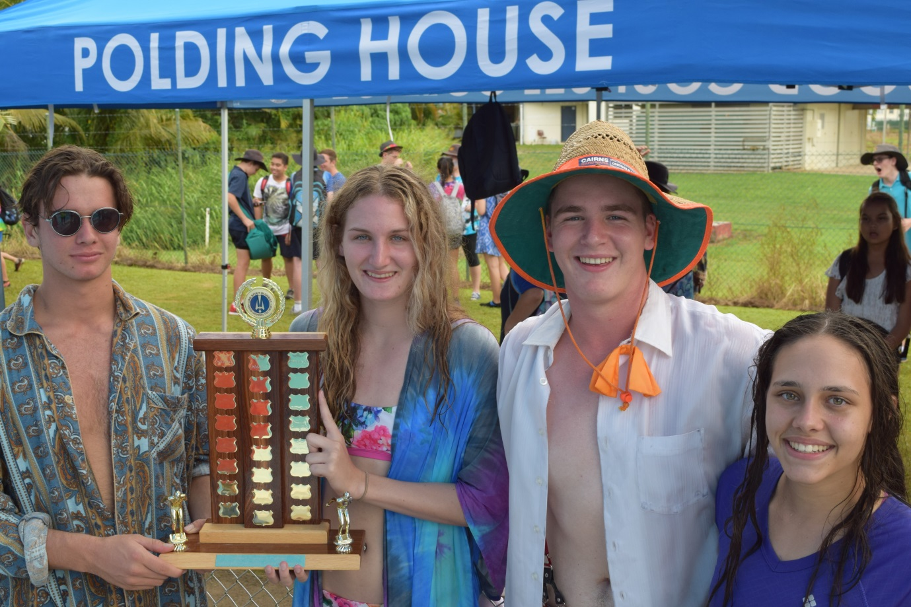
Polding captains: Max Darveniza and Keely Jones & McKillop captains: Tazmon McRobbie and Lori Favero

