DISTRICT TOUCH TRIALS
On the 19th of February the Innisfail District touch trials were held at the Wangan sports fields. Good Counsel College entered an open boys and girls team and an under 15 boys and girls team. Each of the teams played very well throughout the carnival with a couple of wins and losses. A number of students were selected as part of the district team to go to peninsula trials in the upcoming weeks.
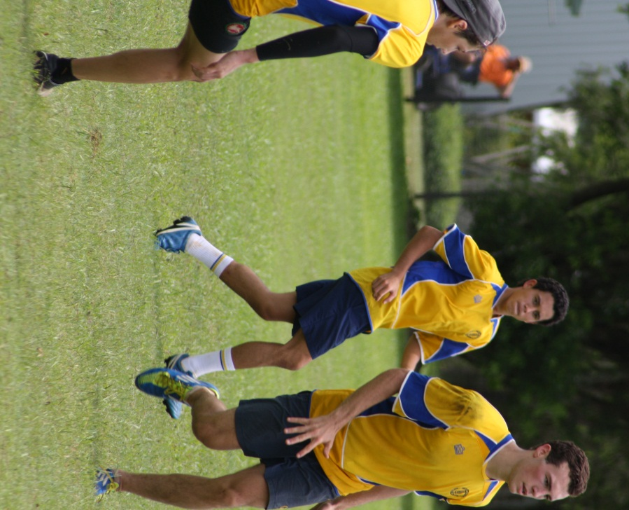
Congratulations to ...
Under 15 girls: Zazzee Abraham, Brianna Milani, Abbey Hurney, Gabrielle Holder and Rebecca O’Connor.
Under 15 boys: Ashton Galea and Ryan Bennett
Open girls: Jessica-Lee O’Connor, Louise Smith and Sophie Dean.
Open boys: Ryan King, Jacob Hurney and Riley Brodie

