VICKI WILSON CUP NETBALL 2013
The Good Counsel College netball teams have again impressed at the Vicki Wilson Cup held on Thursday 25th July in Cairns, continuing to prove that they have got the skill and determination to mix it with the best teams in the Far North. After an excellent start to the year winning the district trials in both the open and under 15 categories, they headed to Cairns with high hopes.
Each team played six games throughout the day in their pool, with the 15s going through undefeated and the opens winning their pool on count back points. The finals were fast and highly skilful with both teams scoring goal for goal during the first half. Unfortunately, the under 15s went down 14 to 9 against St. Andrews and the open girls were defeated by a very well drilled Trinity Bay State High School team. To have both teams reach the finals was an excellent achievement from 15 teams in the under 15 competition and 14 teams in the opens.
On Monday 29th the girls again played together taking on the netball team from Queen Elizabeth School (UK) in the Champagnate Centre. The under 15s played the first two quarters winning convincingly 16 to 6 and the opens followed winning 16 to 10. The games were played in good spirit and were a really enjoyable experience for our netball players. Thank you to all the players and their families for hosting the travelling team and setting such a good example for our school.
The girls will now look forward to the Mossman 7s competition in term 4 when we will aim to defend our title in the under 14s and go one better in the opens to take out first this year.
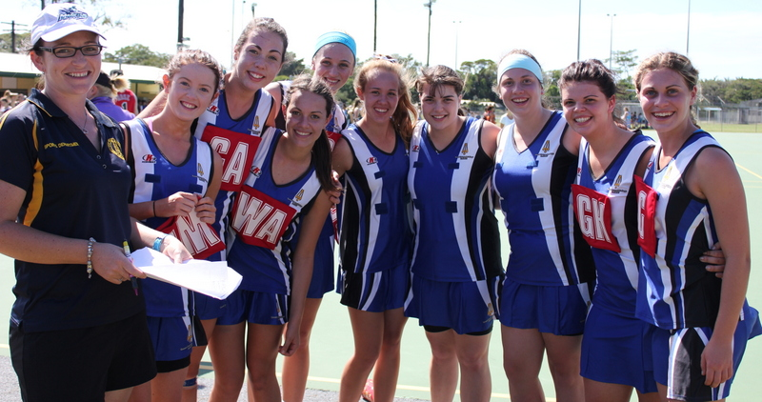
Miss Haren
Open Girls team: Shay-Lee Plath, Caitlin Braithwaite, Micaela Crompton, Emily Boevink,
Adrienne Worth, Madison Beare, Lauren Braithwaite, Kayla Zecchinati and Jessica-Lee O’Connor.
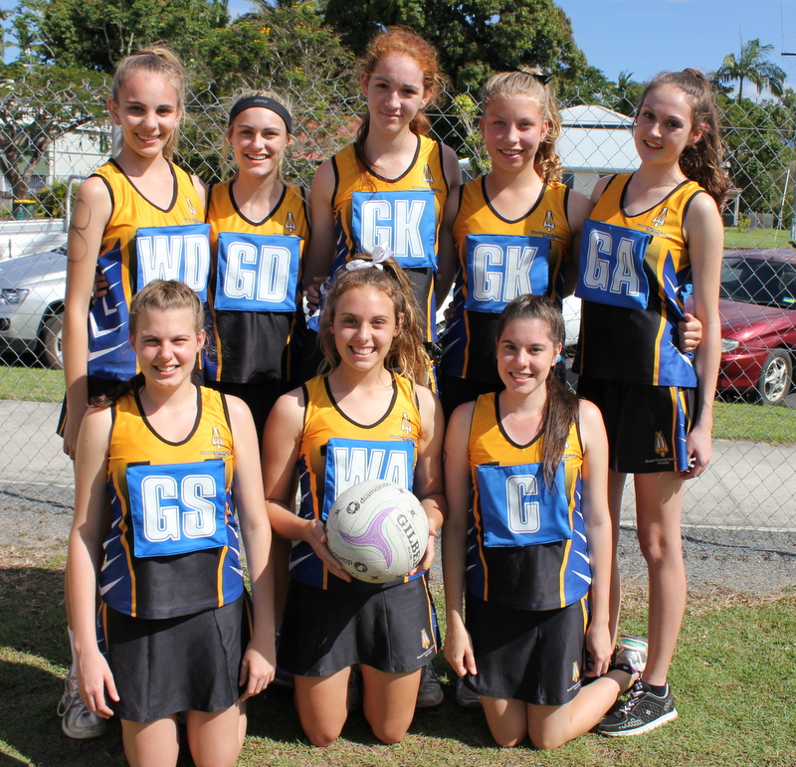
Under 15 team: Laken Ruddell, Rebecca O’Connor, Chyra Zecchinati, Gabrielle Holder, Phoebe Hooker. Front: Breanna Fahey, Abbey Hurney and Brittany Fahey.

